Case Report
Scarring Alopecia Associated with Continuous Use of Alkaline Hair Relaxers: A Case Report of Comfort Centred Management
Andreia Nascimento da Silva ¹
¹Ambulatório Social IAJr
*Correspondence: deia.n.dasilva@gmail.com
Citation: Silva AN. Scarring Alopecia Associated with Continuous Use of Alkaline Hair Relaxers. Brazilian Journal of Hair Health. 2026;3:bjhh48
doi: https://doi.org/10.62742/2965-7911.2026.3.bjhh48
Received: October 12nd, 2026
Revised: October 14th, 2026
Accepted: October 16th, 2026
Published: October 18h, 2026

Copyright: This content is licensed under the terms and conditions of the Creative Commons Attribution 4.0 International License (CC BY).
Abstract
Alkaline hair relaxers are widely used in Brazil and can injure the scalp. When follicular loss is irreversible, therapeutic goals must be redefined. We report a 35 year old Black man with a seven year history of scarring alopecia associated with continuous use of relaxers containing guanidine hydroxide and sodium hydroxide. The scarred area showed no clinical or trichoscopic signs of inflammatory activity; the main complaints were pruritus, burning, scalp tenderness, xerosis and recurrent follicular papules and pustules on the occipital scalp, consistent with pseudofolliculitis related to close clipper shaving. Over seven months of fortnightly visits, he received a multimodal approach combining microneedling with sterile saline, 660 nm photobiomodulation, clay therapy, topical tonics and scalp care guidance, including less frequent close clipping. Pruritus, burning, tenderness and xerosis improved and follicular lesions became less frequent, while no clinically relevant regrowth occurred. The design does not allow the improvement to be attributed to any single component, and reduced mechanical trauma is a plausible contributor. This case illustrates that, in established scarring alopecia, comfort and scalp health are legitimate therapeutic goals that should be agreed with the patient from the outset.
Keywords: Alopecia; Cicatrix; Hair Preparations; Pruritus; Dermoscopy
Introduction
Alkaline hair relaxers, including products marketed in Brazil for curl loosening, are widely used to change hair texture. Their main active agents are sodium, potassium and lithium hydroxides and guanidine hydroxide, the latter generated at the time of use by mixing calcium hydroxide with guanidine carbonate, and they work at a pH of approximately 12 to 14^{1,2}. Their effect on the hair shaft results from lanthionization, the irreversible conversion of part of the cystine disulfide bonds into lanthionine bonds, which permanently changes hair shape^{2,3}.
The alkalinity that modifies keratin can also injure the scalp. Improper use of relaxers has been associated with irritant dermatitis, pain, chemical burns, inflammation and hair breakage¹, and acute scalp injury during relaxer application can heal with permanent scarring alopecia⁴. Alkalis with a high pH cause liquefactive necrosis and saponification of tissue lipids, which allows the injury to progress in depth⁵. When damage reaches the isthmus and the bulge, the epithelial stem cell compartment responsible for follicular regeneration is lost and the hair follicle is replaced by fibrous tissue, resulting in permanent alopecia⁶.
Chronic relaxer use has also been discussed as a factor associated with central centrifugal cicatricial alopecia (CCCA), a primary scarring alopecia that predominantly affects people of African descent⁷. In clinical practice, distinguishing the sequelae of chemical injury from a concomitant primary scarring alopecia may be difficult without histopathology.
Once follicular loss is established, regrowth is not a realistic goal. Nevertheless, these patients often live with pruritus, burning, trichodynia, xerosis and follicular lesions, symptoms that are rarely described in the literature and that affect quality of life. We report the follow up of a patient whose therapeutic goal was deliberately centred on comfort and scalp health rather than on hair regrowth.
Case Report
Patient information
A 35 year old Black man, Fitzpatrick phototype V or VI, previously healthy, with no known systemic comorbidities and no personal history of autoimmune disease, sought care at the Ambulatório Social IAJr for hair loss of approximately seven years’ duration, accompanied by scalp tenderness, intense pruritus and a burning sensation. He reported a clear history of continuous use of alkaline relaxers containing guanidine hydroxide and sodium hydroxide for more tham 15 years, and hair loss began during this period. There was no history of an acute burn episode, such as pain, erosion or crusting after a specific application. He kept his scalp shaved with clippers set close to the skin.
Clinical and trichoscopic findings
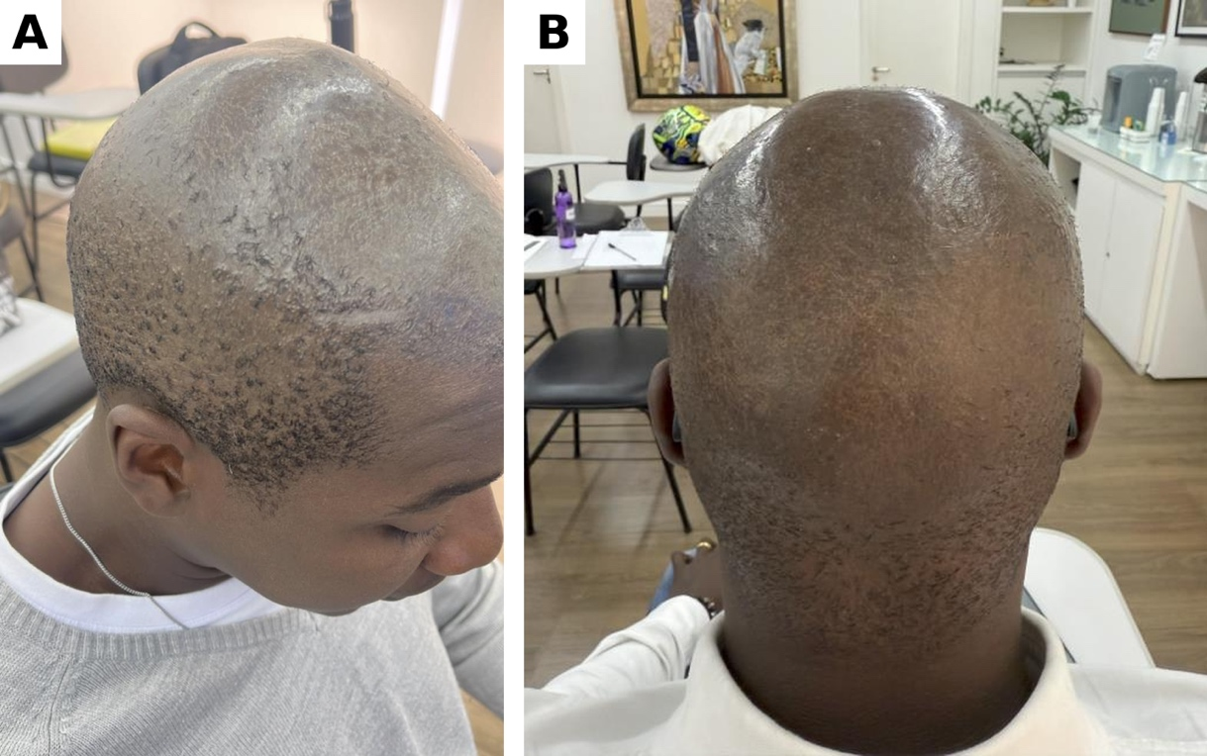
Clinical examination showed an extensive area of scarring alopecia on the vertex, crown and parietal scalp, with intense xerosis (Figure 1). The scarred area showed no signs of inflammatory activity: there was no erythema, perifollicular scaling or pustules. The patient reported recurrent episodes of follicular papules and pustules on the occipital scalp and nape.
Figure 1. Clinical aspect at baseline (April 2025). (A) Lateral view showing extensive scarring alopecia of the vertex and parietal scalp, with xerosis and follicular papules at the margin of the alopecic area. (B) Posterior view.
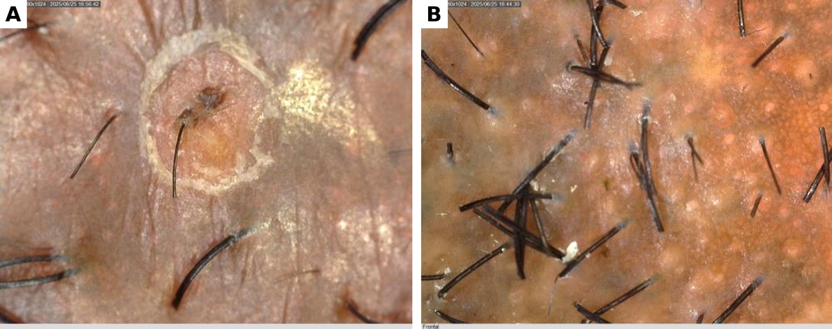
Trichoscopy (60x magnification) of the alopecic area showed areas devoid of follicular openings, without perifollicular erythema, perifollicular scaling or pustules (Figure 2B). A single perifollicular pustule was observed on the occipital scalp (Figure 2A), consistent with pseudofolliculitis or mechanical folliculitis related to close clipping, and was not considered a sign of scarring alopecia activity. The honeycomb pigment network and regular pinpoint white dots, also present, are usual features of the scalp in dark phototypes, corresponding to epidermal pigmentation and to eccrine and follicular openings, and were not interpreted as signs of fibrosis^{8,9}.
Figure 2. Baseline trichoscopy. (A) Single perifollicular pustule on the occipital scalp, consistent with pseudofolliculitis related to close clipping. (B) Honeycomb pigment network and regular pinpoint white dots, normal features of dark scalp, next to an area devoid of follicular openings, without perifollicular erythema or scaling.
Diagnostic assessment
The condition was interpreted as stable scarring alopecia without inflammatory activity, associated with continuous use of alkaline relaxers, with recurrent occipital follicular lesions consistent with pseudofolliculitis caused by close clipping¹⁰. The absence of activity makes an evolving primary scarring alopecia unlikely, but does not exclude burnt out CCCA, whose relationship with relaxers is debated^{7,9}. For the occipital lesions, acne keloidalis nuchae was considered in the differential diagnosis, given their location and the habit of close clipping¹¹. No biopsy was performed.
Therapeutic intervention
Follow up began on April 16, 2025, with fortnightly visits, and continued until November 19, 2025. The therapeutic goal agreed with the patient was to control symptoms and follicular lesions and to improve the condition of the scalp skin, not to obtain regrowth. The interventions are summarized in Table 1.
Table 1. Interventions used during follow up.
Intervention | Description | Frequency | Aim
Microneedling | Microneedling with sterile saline as the only vehicle, without active agents; (derma roller 0,5mm) | Fortnightly  16 essions | Stimulation of skin remodelling
Photobiomodulation | Low level laser, 660 nm, over the entire scalp; ECCO Hair | Fortnightly  16 sessions | Modulation of inflammation and tissue repair
Clay therapy | Black clay with essential oils of Cedrus atlantica and Rosmarinus officinalis, followed by steam and high frequency current | Fortnightly  16 sessions | Comfort and control of follicular lesions
Topical tonic 1 (home care) | Phyllanthus emblica, amino acids, biotin, dexpanthenol, seaweed, IGF, bFGF and caffeine | Daily, April to Every two weeks 2025 | Topical support
Topical tonic 2 (home care) | Caffeine, green tea, ginseng, vitamins and minerals | Daily, from April 2025 to November 2025 | Relief of pruritus and tenderness
Scalp care guidance | Appropriate washing frequency; less frequent close clipping to reduce mechanical friction | Continuous | Prevention of follicular lesions
bFGF, basic fibroblast growth factor; IGF, insulin like growth factor.
Follow up and outcomes
Over seven months, the patient reported progressive reduction of pruritus, burning, trichodynia and tenderness, and follicular lesions became less frequent. Xerosis and scaling decreased and skin texture improved (Figures 3 and 4). The alopecic area did not change in a clinically relevant way: discrete, isolated regrowth was observed only where follicular openings were preserved, consistent with remaining follicles rather than regeneration of the scarred area, and insufficient for cosmetic coverage. The clinical course is summarized in Table 2. No adverse events were observed. Follow up was discontinued after November 2025 because of a change in the patient’s work routine.
Table 2. Timeline of the clinical course.
Period | Clinical course
April 2025 | Start of follow up. Established scarring alopecia without inflammatory activity, intense xerosis, pruritus, trichodynia and recurrent occipital follicular lesions.
June 2025 | Reported reduction of pruritus and tenderness; less xerosis on examination.
November 2025 | Sustained improvement in comfort and skin texture; fewer follicular lesions; scarring alopecia unchanged, with discrete isolated regrowth where follicular openings were preserved.
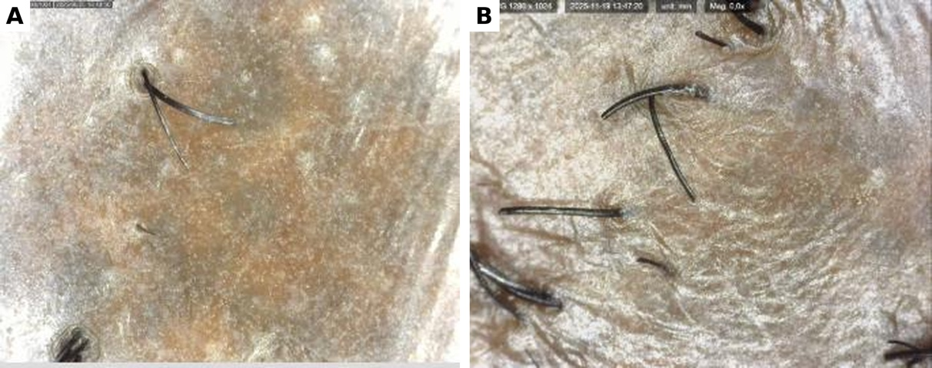
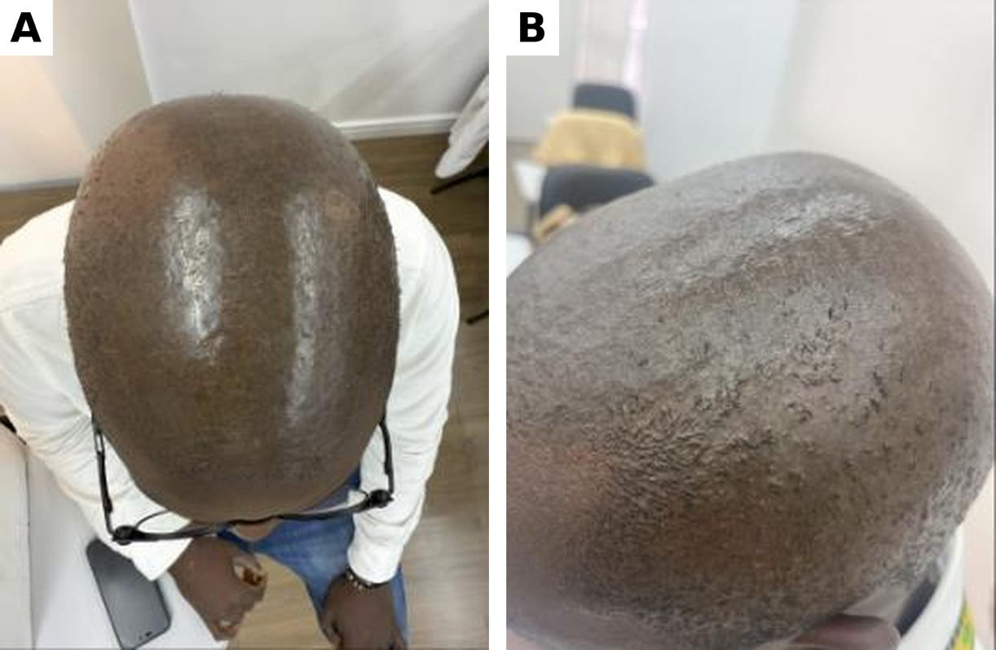
Figure 3. Comparative trichoscopy. (A) April 2025, showing xerosis and scaling. (B) November 2025, showing less scaling and an improved skin surface.
Figure 4. Clinical aspect at the end of follow up (November 2025). (A) Superior view. (B) Lateral view, showing improved skin texture and less xerosis.
Discussion
The main lesson of this case is that, in established scarring alopecia, a good outcome may not involve hair. The patient’s main burden was pruritus, burning and follicular lesions, and it was in these domains that improvement occurred.
The literature on scarring alopecias focuses on controlling inflammatory activity and preserving the remaining follicles^{6,7}. Symptoms that persist after the disease becomes stable, and the quality of the scarred skin, receive far less attention. Defining from the outset a goal compatible with the pathophysiology avoids promises of regrowth and allows real gains for the patient to be valued.
The reduction in follicular lesions has a simple and plausible explanation: the advice to reduce close clipping. Mechanical trauma from close shaving is a recognized factor in pseudofolliculitis and acne keloidalis nuchae in men of African descent^{10,11}. This zero cost measure probably contributed as much as the procedures. The improvement in xerosis may largely reflect the emollient and occlusive effect of the applied products.
The specific contribution of microneedling and photobiomodulation cannot be assessed in this case. There are also safety considerations: microneedling over active follicular lesions may favour bacterial spread and, in dark phototypes prone to keloid formation, may worsen scarring, and essential oils applied to a compromised barrier are potential irritants and sensitizers.
This report has limitations. There was no histopathological confirmation, so the chemical aetiology is presumed from the history and burnt out CCCA cannot be excluded. Outcomes were assessed qualitatively, without validated scales, by the same professional who delivered the treatment. Several interventions were applied simultaneously, which prevents attribution of the effect to any of them. The improvement may also reflect regression to the mean, seasonal variation and the natural history of a stabilizing scar. Follow up lasted seven months and ended without later assessment, and the photographs were not obtained under standardized conditions.
Conclusion
In this patient with stable scarring alopecia associated with continuous use of alkaline relaxers, seven months of multimodal care coincided with reported improvement in pruritus, burning, xerosis and the frequency of follicular lesions, without clinically relevant regrowth. The design does not allow the improvement to be attributed to any single component, and reduced close clipping is a plausible explanation for part of the result. When follicular loss is irreversible, comfort and scalp health are legitimate therapeutic goals that should be agreed with the patient from the outset.
References
1. de Paula JNH, Basílio FMA, Mulinari-Brenner FA. Effects of chemical straighteners on the hair shaft and scalp. An Bras Dermatol. 2022;97(2):193-203. doi:10.1016/j.abd.2021.02.010
2. Robbins CR. Chemical and physical behavior of human hair. 5th ed. Berlin, Heidelberg: Springer; 2012. doi:10.1007/978-3-642-25611-0
3. Bolduc C, Shapiro J. Hair care products: waving, straightening, conditioning, and coloring. Clin Dermatol. 2001;19(4):431-6. doi:10.1016/S0738-081X(01)00201-2
4. Khumalo NP, Pillay K, Ngwanya RM. Acute ‘relaxer’-associated scarring alopecia: a report of five cases. Br J Dermatol. 2007;156(6):1394-6. doi:10.1111/j.1365-2133.2007.07893.x
5. Palao R, Monge I, Ruiz M, Barret JP. Chemical burns: pathophysiology and treatment. Burns. 2010;36(3):295-304. doi:10.1016/j.burns.2009.07.009
6. Harries MJ, Paus R. The pathogenesis of primary cicatricial alopecias. Am J Pathol. 2010;177(5):2152-62. doi:10.2353/ajpath.2010.100454
7. Olsen EA, Callender V, McMichael A, Sperling L, Anstrom KJ, Shapiro J, et al. Central hair loss in African American women: incidence and potential risk factors. J Am Acad Dermatol. 2011;64(2):245-52. doi:10.1016/j.jaad.2009.11.693
8. Rudnicka L, Olszewska M, Rakowska A, editors. Atlas of trichoscopy: dermoscopy in hair and scalp disease. London: Springer; 2012. doi:10.1007/978-1-4471-4486-1
9. Miteva M, Tosti A. Dermatoscopic features of central centrifugal cicatricial alopecia. J Am Acad Dermatol. 2014;71(3):443-9. doi:10.1016/j.jaad.2014.04.069
10. Perry PK, Cook-Bolden FE, Rahman Z, Jones E, Taylor SC. Defining pseudofolliculitis barbae in 2001: a review of the literature and current trends. J Am Acad Dermatol. 2002;46(2 Suppl):S113-9. doi:10.1067/mjd.2002.120789
11. Ogunbiyi A. Acne keloidalis nuchae: prevalence, impact, and management challenges. Clin Cosmet Investig Dermatol. 2016;9:483-9. doi:10.2147/CCID.S99225
Patient Consent
Written informed consent was obtained from the patient for the publication of this case report and the accompanying images
Acknowledgments
None.
Management of Conflicting Interests
The topical products used in this case were donated by TrichoRES. The author declares no other conflicts of interest.
Financial Support Disclosure
This research received no specific grant from any funding agency in the public, commercial or not for profit sectors.
Declaration of Generative AI Use
Generative artificial intelligence (Claude, Anthropic) was used to assist with language editing, translation into English and formatting. The author reviewed all content and takes full responsibility for the manuscript.

